|  |
| --- |
| Faculty of Science and Technology  BSc (Hons) Games Design  Date of submission: xxx  Assignment title: Web Application and Report  Student name Klaris Shtambari  Student ID: s5317311 |

1. **Assignment Aims and Objectives**

The aim for this assignment is to display individual portfolio under a website format.

This requires students to build a website from groundwork utilising different styling pages and scripting languages that have been taught in lesson, which are HTML, CSS and JAVASCRIPT.

The assignment gives the students total freedom on the design and the format of the website, however it needs to include a CSS style page as well as at least three navigation tabs and consistent header and footer.

My aim for the website is:

* Create an interactive header with the following subdivisions:
* Home
* About Me
* Portfolio
* Contact Me
* Have some animation in the index page and on other pages in order to make the design more appealing to the user.
* On the portfolio subdivision I want to add some brief commentary on my previous work.
* On the Contact Me page I want to add the logos of each social media and make the user interact with them in order to make the experience more dynamic.

I saw some work from the internet in order to get a clear idea on the structure of the header.

On YouTube, I saw a video of “Web Dev” which guided his viewers step by step on creating a homepage for a travelling agency, however I liked the style of the header therefore I decided to implement some of his code on my work in order to get a similar result, tweaking the necessary bits to suit my purpose.

1. **Assignment Implementation**

I started this project without a clear design in mind, but I knew I wanted to start with a logo and an interactive intuitive header for the user to navigate throughout my pages with ease.

**2.1** **Methods**

I stumbled upon some work from the internet in order to get a clear idea on the structure of the header.

On YouTube, I saw a video of “Web Dev” which guided his viewers step by step on creating a homepage for a travelling agency, however I liked the style of the header therefore I decided to implement some of his code on my work in order to get a similar result, tweaking the necessary bits to suit my purpose. (1)

Second step in my creation was to implement a theme or design throughout the whole website, therefore I started searching some companies with a strong present online as they would have invested a lot of time and effort on their webpages, and I ended up enjoying the design of a clothing company, called “Studio Bagaz”. (2)

After implementing a thorough theme, I had to populate my website, consequently I started filling my “about me” subdivision and “contact me” as they were the easiest.

Next, I moved to the portfolio Subdivision which is the page the includes most scripting and interaction. I took inspiration of the format from online lessons at the University as the professor was showcasing expandable boxes on hover.

**2.2 details**

I will divide this section in 4 different categories:

* **Index**

The index was simple to create. I started with a picture of myself and a video of a VFX work I did back in college, just to introduce the user to some of my work.

I created two different rectangles of contrasted coloured and made them collide with an animation from left to right and vice versa. I used both HTML and CSS to achieve this result.

* **About me**

This page only includes some text and some visual representation to structure the information in a concise way.

I used both HTML and CSS in order to align the text in the middle and add a semi box to contain it.

* **Portfolio**

This page proved to be the most challenging as it included dynamic boxes with pictures and information.

I managed to create a box which enlarges when the user hovers it and it shows the information of the text which disappears after the box folds back into original position.

This was achieved by using HTML, CSS and Javascript.

* **Contact me**

This page was similar to the “about me “section as it only includes some text with interactive pictures which delivers the users to my social medias.

I only utilised HTML and CSS for this.

**2.3 Issues**

During my developing I have encountered a major issue, I work on two different sized monitors and while coding on one I was using the second as a display of the results, however when I tried reversing their role I noticed that the format was a bit messed up therefore I tried fixing it on one and it kept backfiring.

This mainly happened on the portfolio website where the images didn’t align properly inside the boxes.

Here is a visual representation of my issue :

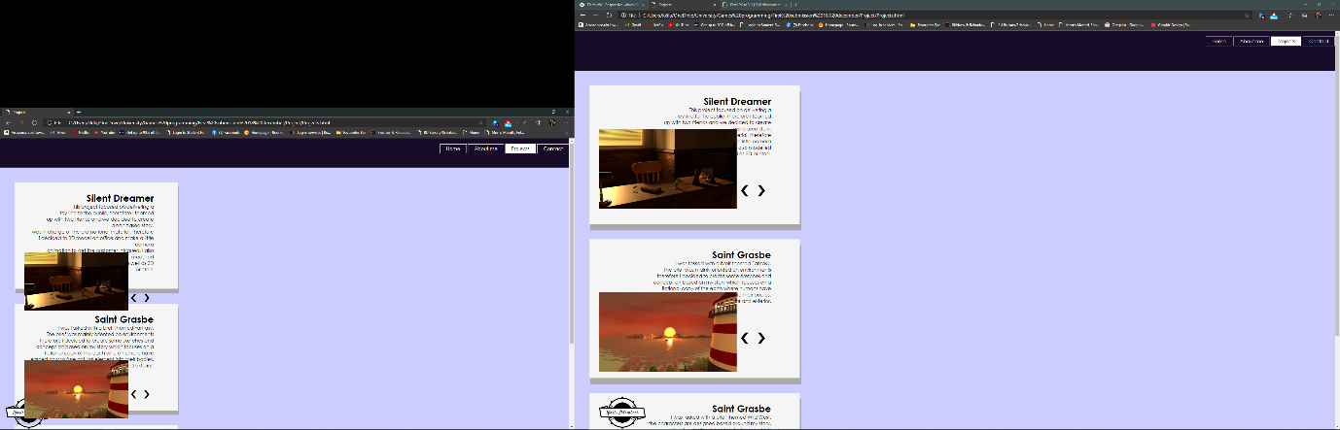

It is noticeable that on the picture on left supresses the format in a way that pushes the images outside the box.

I tried reading different forums and I noticed that there are no “universal” sizes for different monitors therefore I just had to go and work with my monitors. (3)

I also came up with other issues such as using a control version to upload my files, therefore I utilised Onedrive to upload everything online and proceeded to continue uploading files manually to my GitHub Repository.

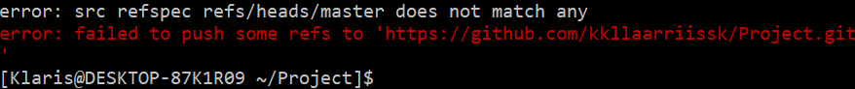

1. **Results**

Here are the results for the different pages:

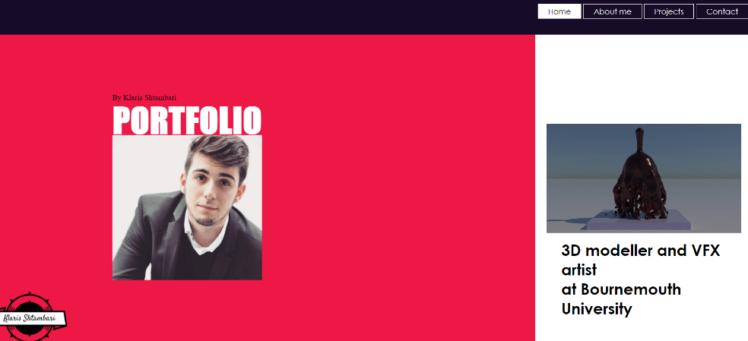

Index

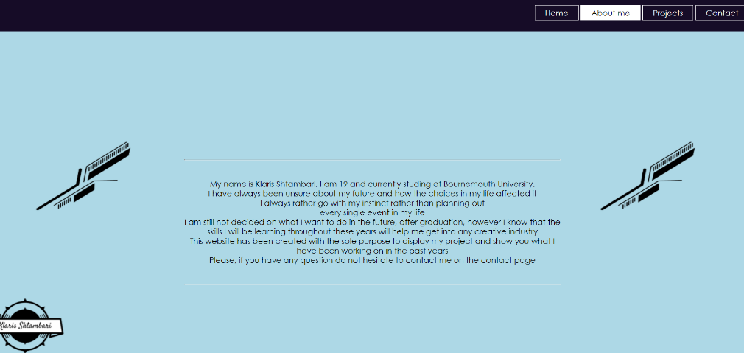

About me

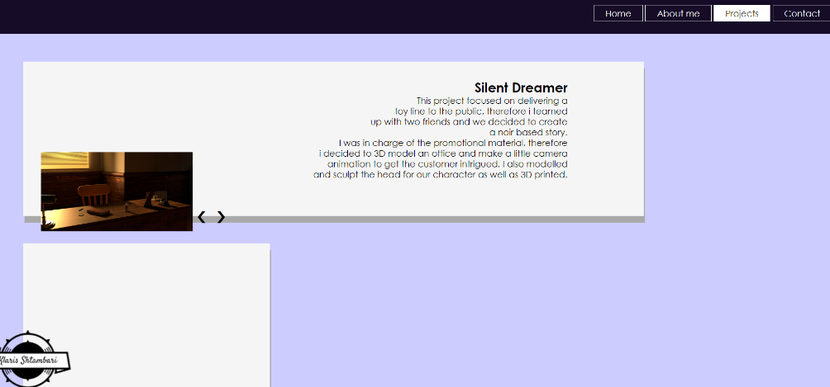

Projects

(I am using a travelling laptop, therefore the format is even more messed up)

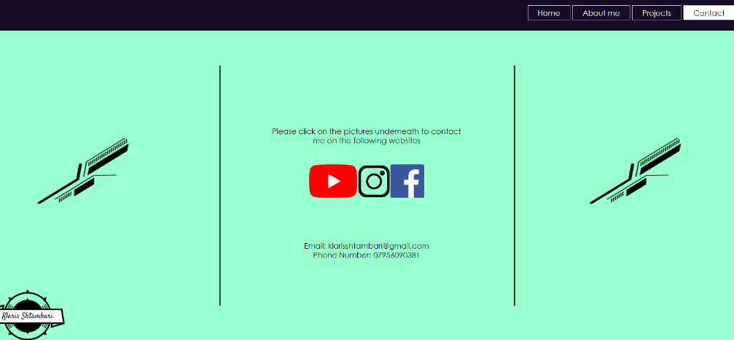Contact me

1. **Critical Evaluations**

I did not have a plan or design in mind as already mentioned, however I kept getting inspiration by different websites which helped me to reach my original goals, therefore I am pretty satisfied with the product, even though I have had issues with the format.

**References**

1. [How To Create A Website Using HTML And CSS Step By Step Website Tutorial - YouTube](https://www.youtube.com/watch?v=uyaV_EWWRmo&ab_channel=Webdev)
2. [Graphic Design | Studiobgz.com | סטודיו בגאז׳](https://www.studiobgz.com/)
3. [javascript - How to make font size independent of screen resolution and monitor size? - Stack Overflow](https://stackoverflow.com/questions/16245346/how-to-make-font-size-independent-of-screen-resolution-and-monitor-size)